PROGRAM OF ORDERING REGIONAL ECOLOGICAL FROM NAYARIT 2022 Registration of participants SECTOR WORKSHOP
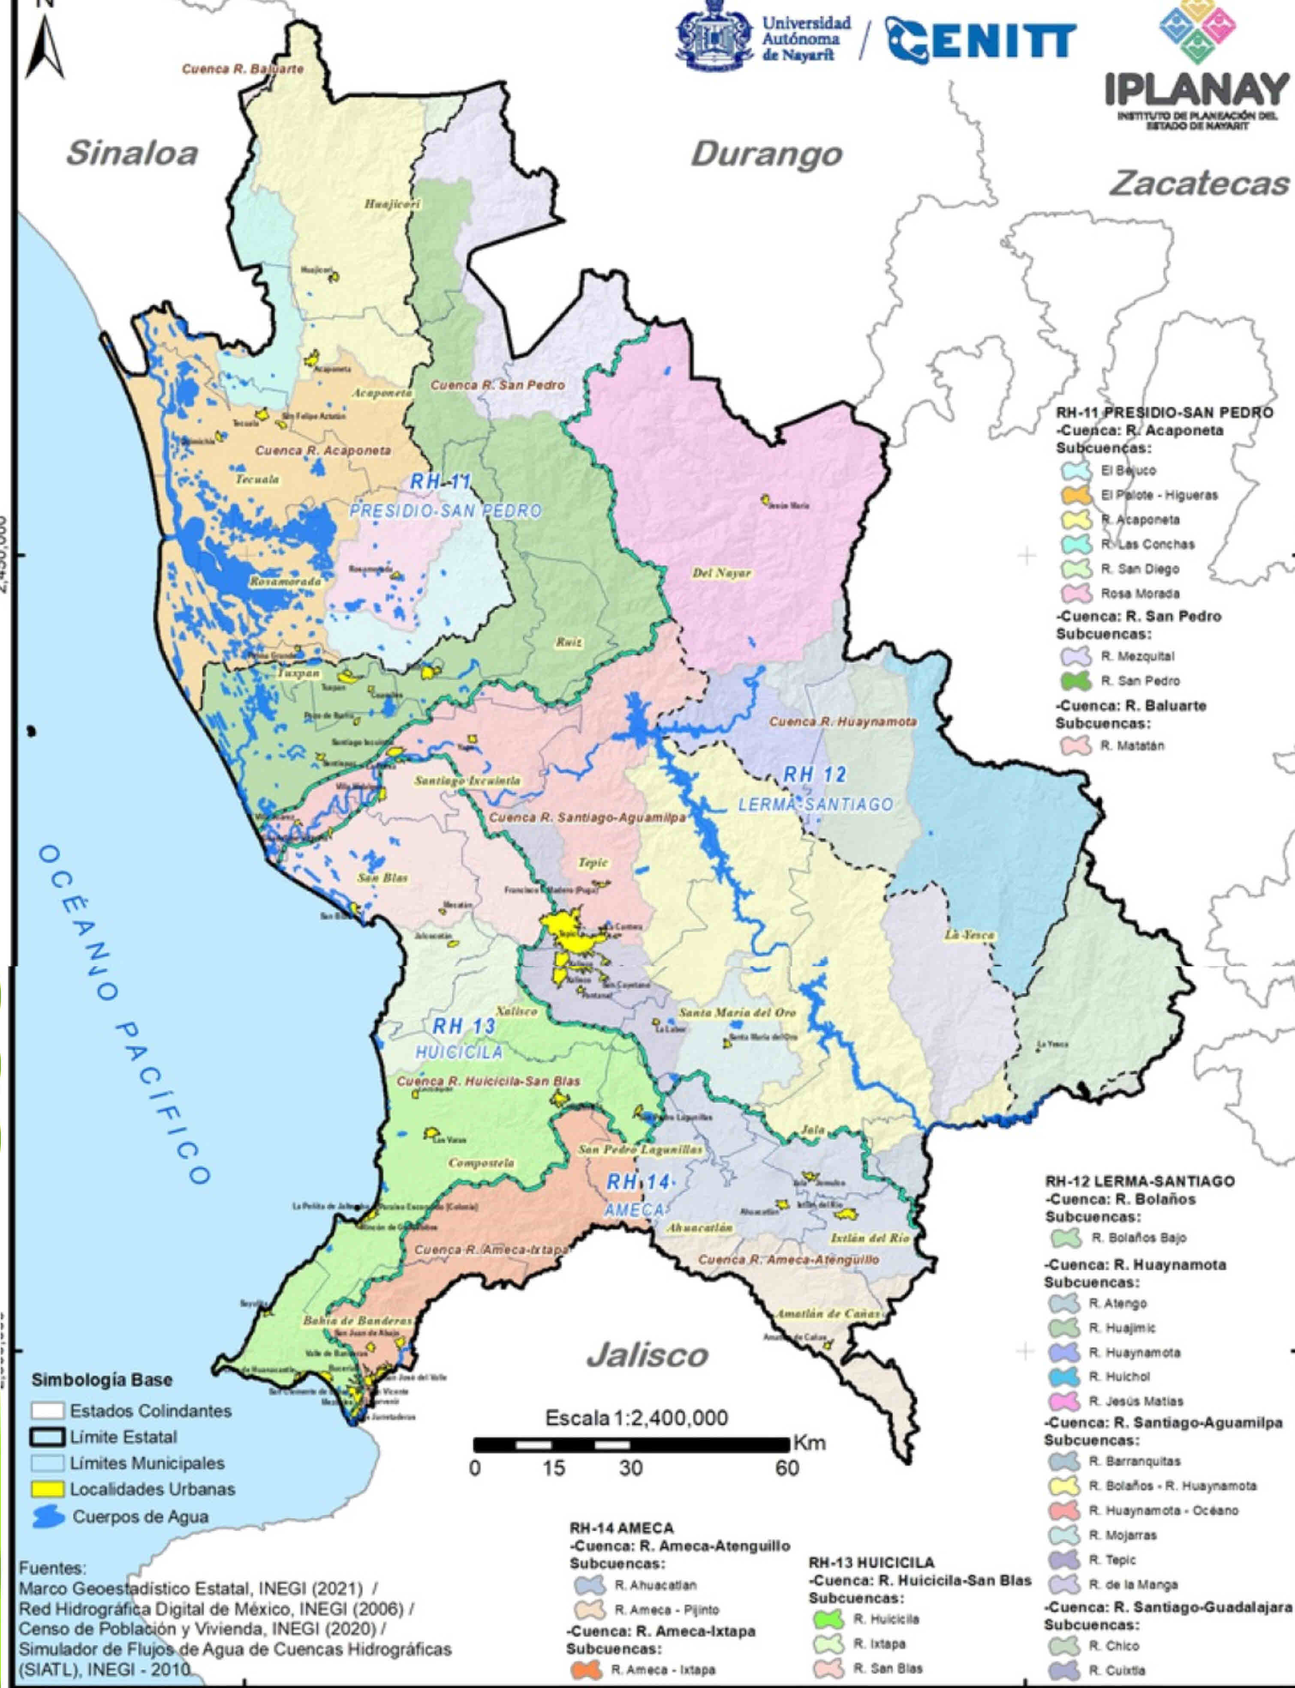

Who will participate in the workshop?
The representatives of peasant organizations,
livestock, fishing, aquaculture, forestry, tourism and
conservation, settled in the state of Nayarit, the
independent producers, NGOs, the academic sector,
as well as dependencies of the three orders of government and
anyone interested in the ordering of the
region.
How will this workshop take place?
Once the sectors related to the
use of natural resources, the
maintenance of environmental goods and services, the
conservation of ecosystems and biodiversity in the area
ordering; They are invited to expose both their interests,
as the environmental attributes necessary for the development
of their activities. The sectors collegiately prioritize
environmental attributes and identify conflicts with
other sectors.
What comes after the workshop?
Based on the results of the workshop, the
stage of Characterization, and in the stage of Diagnosis,
they will build the aptitude maps of the territory, as well as the
conflict maps between sectors; those who will be validated
in a second workshop to which they will be invited
participants.
Where will the workshops take place?
In the municipal seats of each of the
20 Municipalities of the State of Nayarit
When will the workshop be?
Visit the page https://cenitt.uan.mx/ to see the calendar
complete, with date, time and place where the workshop will be held
in each of the 20 municipalities or contact the
telephones 311- 129 5300 of the IPLANAY or 311 1804811 of the
CENITT
09:30 - 10:00 registration of participants
10:00 - 10:15 Welcome by the President Municipal.
10:15 - 10:40 Explanation of Reasons by the Secretariatof Sustainable Development of Nayarit.
10:40 - 11:00 Presentation of methodology and dynamics of the Workshop.
11:00 - 11:45 Working Groups: Consensus of interest
11:45 - 12:00 sector, presentation of problems of the sector.
12:00 - 12:45 Break.
12:45 - 13:15 Matrix of conflicts between sectors, attribute identification and weighting.
13:15 - 13:30 conclusions.
Visit our website
https://cenitt.uan.mx/
For any questions, contact the phones
311- 129 5300 del IPLANAY o al 311 1804811 del
CENITT.
What is Territorial Ecological Planning?
Territorial Ecological Planning is an instrument of
environmental policy, whose primary objective is to induce the use
of the land and the productive activities of the territory,
considering the interests and conflicts that exist between the
various sectors of society in the area of application,
seeking to reduce these conflicts.
What is the Ecological Ordinance Program of
Nayarit?
It is a planning instrument in the process of elaboration
that will contain the objectives, priorities and actions that
regulate or induce land use and activities
productive of each region, and that allows in these terms
planning, environmental protection, as well as
the preservation and sustainable use of the
natural resources of the State of Nayarit.

Where would it apply?
Throughout the state of Nayarit
Who promotes it?
It is a joint effort of the Government of the State of Nayarit, the
Secretary of Sustainable Development of the State of Nayarit a
through the Nayarit State Planning Institute.
What has been done?
For this Ordinance, the stage of:
Diagnosis, in which the current state is described and modeled
of the subsystems, natural, social and economic of the state,
In addition to identifying the sectors present in it (agricultural,
livestock, fishing, aquaculture, tourism, forestry, mining and
conservation), as a result for this Diagnosis,
carry out an analysis of aptitude and conflicts between the sectors
involved in the territory.
General objective:
Know and complement the diagnosis on aptitude
territory of the state, to develop its own activities
of each sector.
SPECIFIC OBJECTIVES
1.- Agree on the interests and activities of each sector that
affect the state territory.
2.- Analyze jointly the problems identified
in each sector and define those of special attention.
3. Identify conflicts between sectors using the matrix
of intersectoral conflicts.
4. Know and complement the spatial attributes (variables)
that make up each sectoral activity.
5. Prioritize the attributes of each sectoral activity and
integrate them to territorialize them in a fitness map by
each activity carried out by the sector.
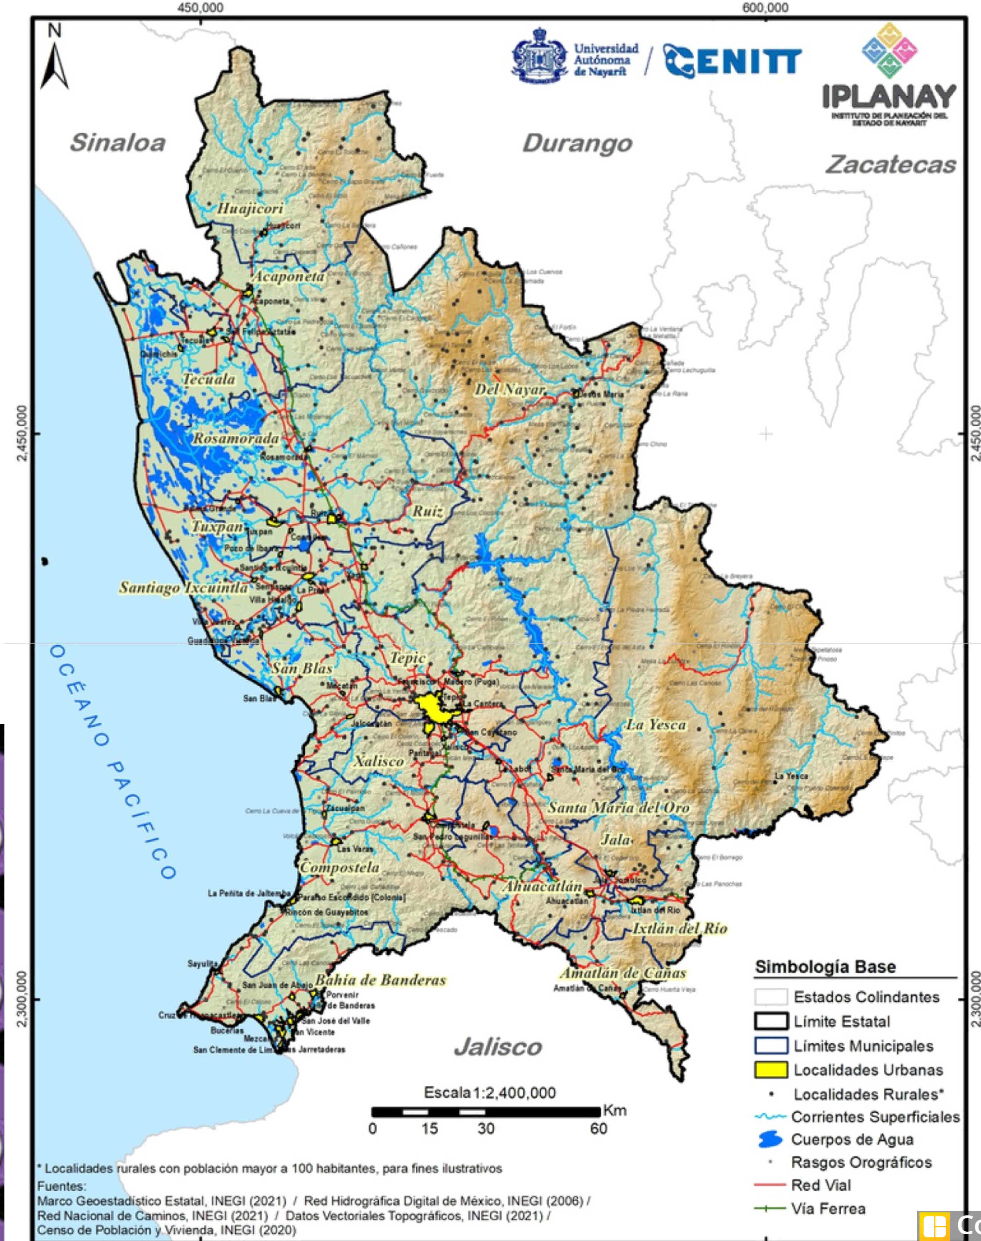

What are the expected results of this Workshop?
Have a complete and agreed Diagnosis on aptitude
territory of the state, to develop the activities of
each sector.
Why a Sector Workshop?
To ensure that information is obtained that reflects
faithfully what happens in the state, it is necessary that the
inhabitants, participate and corroborate, complement or validate
the information generated in the development of the program, and
thus obtain a reliable product.
