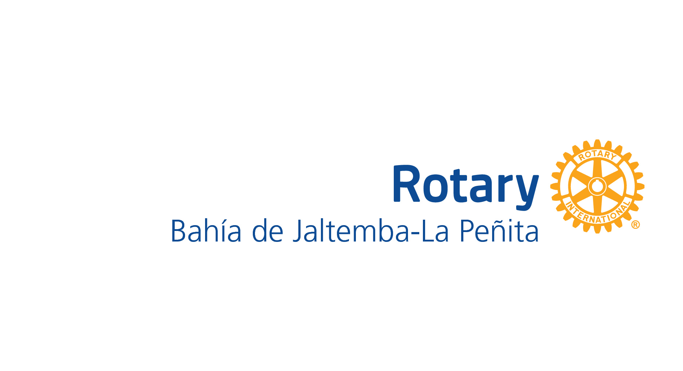

In Mexico there are two separate but unequal school systems. One is Secretaría de Educación Pública (SEP) the main school system that has over 18 students per classroom and the other is CONAFE (Consejo Nacional de Fomento Educativo) with 4 to 17 students that is a decentralized agency of SEP (English: Ministry of Public Education), whose task that is not in the SEP schools, is to provide basic education services from early childhood to children between zero and three years eleven months old and to children and adolescents living in areas of high and very high marginalization of the country, where it is not possible to have a regular educacional servicie.
It has come to our attention through communicating with two supervisors of CONAFE schools and visiting of various schools in the CONAFE school system (National Council for the Promotion of Education) that the needs of these schools are not met as other SEP schools. However, depending on the involvement of the parents and the towns, some schools have facilities up to standard. They all lack the daily consumables like crayons, tablets, workbooks, notebooks, paper, pencils, markers etc.
THE FOLLOWING IS OF THOSE SCHOOLS THAT DO NOT HAVE FACILITIES UP TO STANDARD OR NEED ADDITONAL MATERIALS.

NECESIDADES DE LAS ESCUELAS

RESERVA NATURAL DEL PALMAR
OBJETO | CANTIDAD | PRESUPUESTO
MESAS DE TRABAJO/TABLES | 5 (1chico 1 grande) | $ 4,900
SILLAS PARA LOS ALUMNOS/CHAIRS | 5 | $ 4,900
ESTANTES PARA MATERIAL DE CONSUMO/SHELVING | 2 | $4,000
PINTURA/PAINT | 2 CUBETAS | $ 1,300 ea.

DIVISADERO
OBJETO | CANTIDAD | PRESUPUESTO
ESTANTES PARA MATERIAL DE CONSUMO/SHELVING | 2 | $ 4,000
PINTURA/PAINT | 2 CUBETAS | $ 2,600
COLORES/PAINT | 7 | $ 280
CRAYOLAS | 4 | $ 180
PLUMONES/MARKERS | 5 | $ 300
HOJAS BLANCAS/WHITE PAPER | 3 PAQUETES | $ 450

CHULAVISTA
OBJETO | CANTIDAD | PRESUPUESTO
PUERTA PARA EL BAÑO/BATHROOM DOOR; TABLES | 1 | $ 8,000
SPIRAL NOTEBOOKS | 14 | $ 700
COLORES/CRAYONS | 8 | $ 320
LAPICES/PENCILS | 6 | $ 150

PARANAL
OBJECTO | CANTIDAD | PRESUPUESTO
MESAS Y SILLAS 2 + 4 | 2 | $3150 ea.
BAÑO-THERE IS NO BATHROOM BUT THERE IS SPACE. SEE POWER POINT PARANAL, | 2 | COST ESTIMATE IN PROCESS.
MATERIAL DIDACTICO

OTATES

OBJECTO | CANTIDAD | PRESUPEUSTO
TENACO PLATFORM (WATER TANK SUPPORT). TOILET TANK AND SINK. + PLUMING. | 1 | $16,000
VENTILADORES DE PISO/FLOOR FANS | 2 | $1500 ea.
MATERIAL DIDACTICO

EL ESPINO
OBJECTO |  | .
MESAS Y SILLAS 2 + 4 | 2 | $3150 ea
PAINT | 2 | $1350 ea.
MATERIALES DIDACTICO

JOLOTEMBA
OBJECTO
VENTILADORES | 2 | $1500 ea.
MATERIALES DIDACTICO

EL LLANO
OBJECTO
MATERIALES DIDACTICO
MESAS YS SILLAS | 2 | $3150 ea
PAINT | 2 | $1350 ea.

LAZARO CARDENAS
OBJECTO
MATERIALES DIDACTICO
VENTILADORES | 2 | $1500 ea.

Materiales Didactitco – Everyday consumables such as: crayons, tablets, workbooks, notebooks, paper, pencils, markers etc.
Ventiladores - Fans (floor fans)
Mesas y Sillas - Tables and chairs
ESTANTES - SHELVING

