How Rotary International leverages support from outside communities
This is an example of the international fellowship that we all share in Rotary International. Jaltemba Bay is one place where people love to vacation, and to some people that means working to make the world a better place, one tiny corner at a time. This is a story of one family and how they made a huge difference. This same story is repeated all the time in many parts of the world. Good people making a big difference for other people. Some of these Rotarians take vacations in Jaltemba Bay, and they share their stories with us from all over the world. They bring humanity together to accomplish great things, and they prove that we all do better, when we all do better.
Este es un ejemplo del compañerismo internacional que todos compartimos en Rotary International. La Bahía de Jaltemba es un lugar donde a la gente le encanta vacacionar y, para algunas personas, eso significa trabajar para hacer del mundo un lugar mejor, un pequeño rincón a la vez. Esta es la historia de una familia y de cómo marcaron una gran diferencia. Esta misma historia se repite todo el tiempo en muchas partes del mundo. Buenas personas que hacen una gran diferencia para otras personas. Algunos de estos rotarios toman vacaciones en la Bahía de Jaltemba y comparten con nosotros sus historias de todo el mundo. Reúnen a la humanidad para lograr grandes cosas y demuestran que a todos nos va mejor cuando a todos nos va mejor.
Jaltemba Bay Rotary Club found a used Ambulance that they purchased for the Emergency Medical Technicians in Guayabitos. The purchase was made with funds from a Rotary friend from North Carolina. His name is Mark Reinhardt. Mark is the Son of Dale Reinhardt.
Dale did a lot of work in Chacala, Building the first library. Mark and Dale helped establish the Medical Center in Chacala. Dale was involved with the Berkley California group. This year the Berkley group of over 18 clubs made over 27,000 USD donation to the new kindergarten in Los Ayala this year. Please have a look at the great things that the Berkley Group has done over the past 25 years for the education of the community.
Club Rotario Bahía Jaltemba encontró una Ambulancia usada que compraron para los Técnicos de Emergencias Médicas en Guayabitos. La compra se realizó con fondos de un amigo rotario de Carolina del Norte. Su nombre es Mark Reinhardt. Mark es el hijo de Dale Reinhardt.
Dale trabajó mucho en Chacala, construyendo la primera biblioteca. Mark y Dale ayudaron a establecer el Centro Médico en Chacala. Dale estuvo involucrado con el grupo Berkley California. Este año, el grupo Berkley de más de 18 clubes hizo una donación de más de 27.000 dólares al nuevo jardín de infancia de Los Ayala. Eche un vistazo a las grandes cosas que Berkley Group ha hecho durante los últimos 25 años por la educación de la comunidad.
Mark and 2 others from Morehead City Rotary club visited our area. They attended our Big Event, and they did a tour of schools that were helped by the Berkley Club group including CONAFE and previous Berkley projects. They identified a number of schools that need help, and they agreed to work on purchasing 2 school busses for CONALEP (the regional trade school). Mark committed to providing furniture windows, and ventilation Fans for the Zalculpan CONAFE school.

Mark y 2 personas más del club rotario de Morehead City visitaron nuestra área. Asistieron a nuestro Gran Evento e hicieron un recorrido por las escuelas que fueron ayudadas por el grupo Berkley Club, incluido CONAFE y proyectos anteriores de Berkley. Identificaron varias escuelas que necesitan ayuda y acordaron trabajar en la compra de 2 autobuses escolares para CONALEP (la escuela de oficios regional). Mark se comprometió a proporcionar muebles, ventanas y ventiladores para el colegio CONAFE de Zalculpan.

Let me connect the dots: Jaltemba Bay has become a vacation destination location, and a second home for many North Americans. People come from all over the world, but there is an abundance of USA and Canadian tourists and home owners. Rotarians have a special bond with the community. They are concerned about things like un regulated growth, water quality, and the environment. Nevertheless, the largest concern is the education of the next generation of Mexicans, because Education builds bridges to a better future, and it is happening in Jaltemba bay in no small part through the efforts of Rotarians like these gentlemen who have been working on the community for Decades.

Support Rotary, and you support good things across the planet.
Apoya a Rotary y apoyarás cosas buenas en todo el planeta.
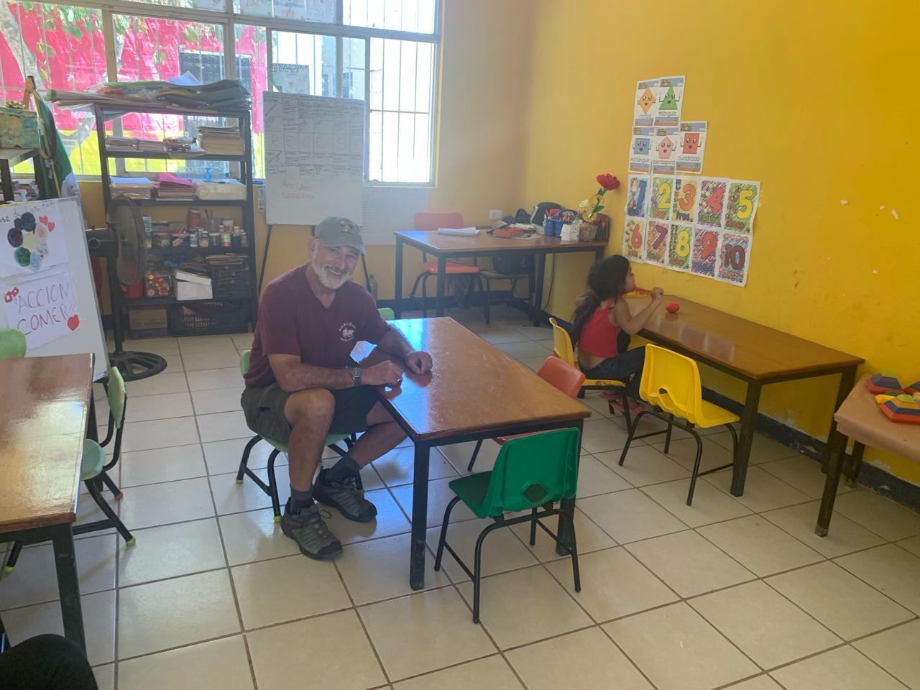
Mark with new school furniture financed by the Berkeley rotary Group, and supporters from the Big Event 2024.
Mark con nuevo mobiliario escolar financiado por Berkeley Rotary Group y simpatizantes del Gran Evento 2024.
Mark is providing funding for the Zalculpan CONAFE school, providing furniture, ventilation fans, and windows for their classroom after he visited this school in early February.
The Morehead City Rotary Club has agreed to persue a grant that would bring 2 school busses to be used for CONALEP students that come to La Penita from as far away as Zalculpan, and Sayulita.
This is how Rotary international leverages the power of people to help with these needed projects. Remember, education builds bridges to better futures for everyone.

Mark está proporcionando fondos para la escuela CONAFE de Zalculpan, proporcionando muebles, ventiladores y ventanas para su salón de clases después de visitar esta escuela a principios de febrero.
El Club Rotario de Morehead City acordó solicitar una subvención que traería 2 autobuses escolares para ser utilizados por los estudiantes de CONALEP que vienen a La Peñita desde lugares tan lejanos como Zalculpan y Sayulita.
Así es como Rotary International aprovecha el poder de las personas para ayudar con estos proyectos necesarios. Recuerde, la educación tiende puentes hacia un futuro mejor para todos.

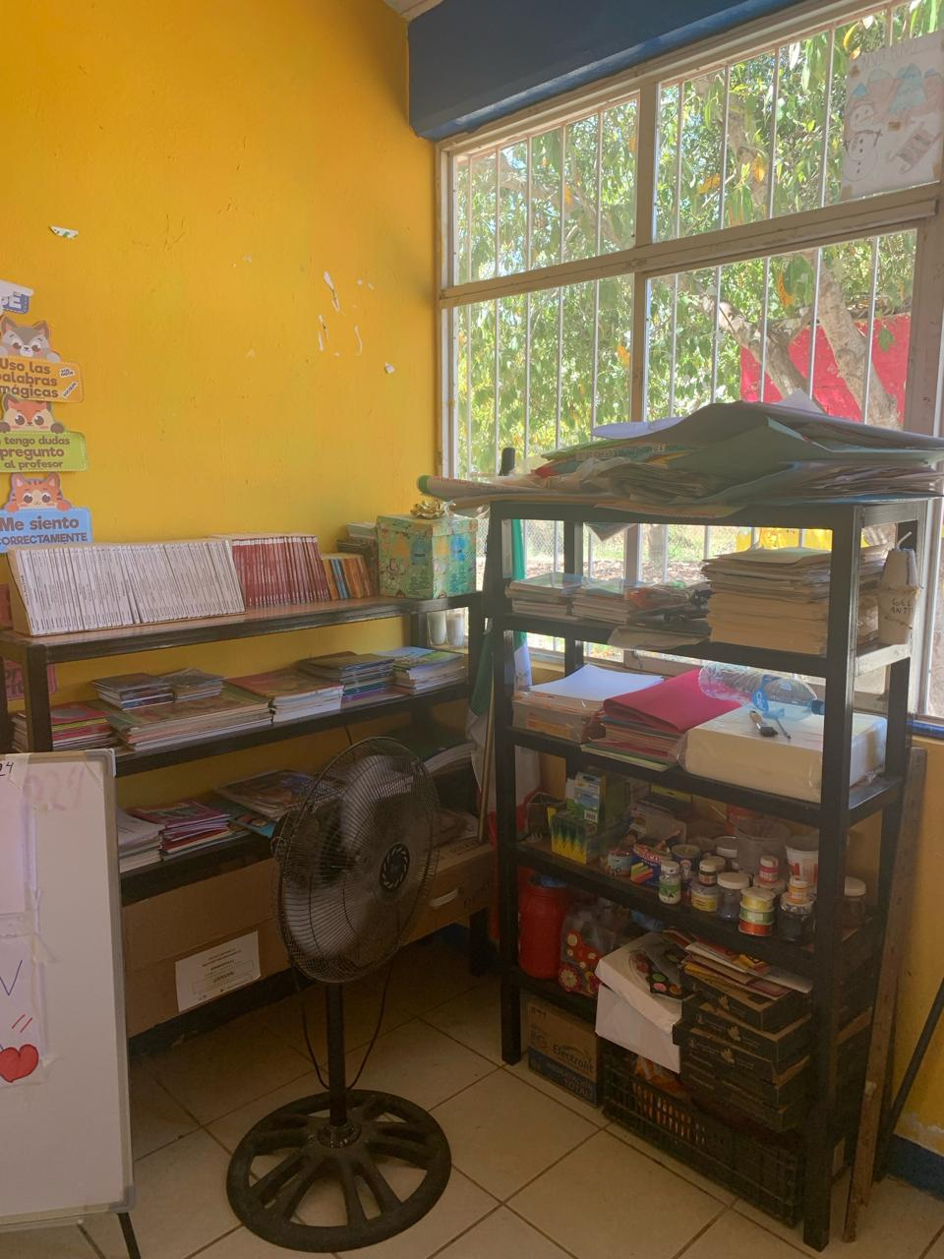
Book shelves built by Rotarians from Berkley, and Jaltemba Bay- Estanterías para libros construidas por rotarios de Berkley y Jaltemba Bay
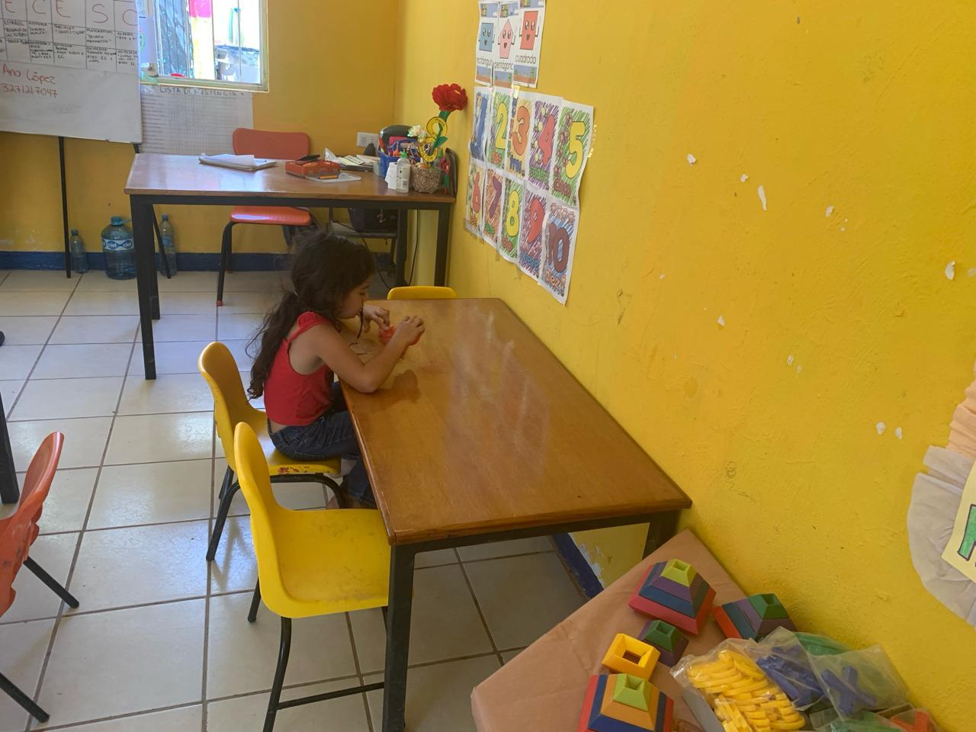
Teachers Desks and student Desks- Escritorios de profesores y escritorios de estudiantes
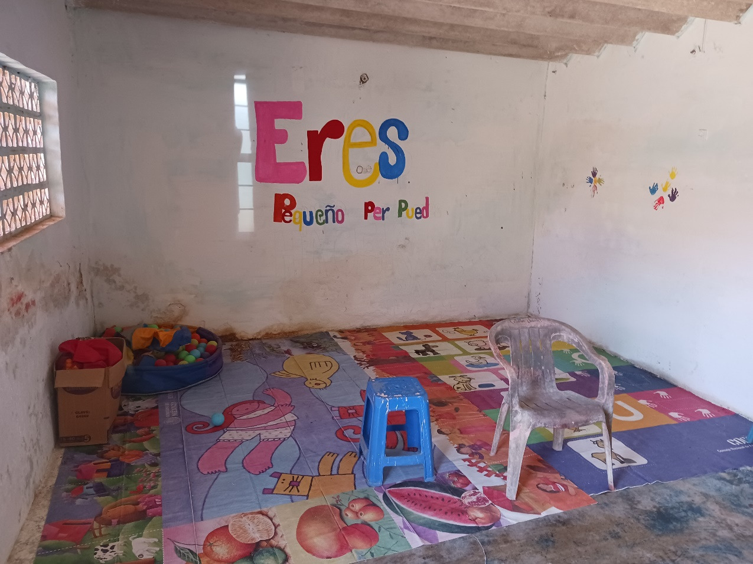
CONAFE schools before furniture distribution - Escuelas CONAFE ante distribución de muebles
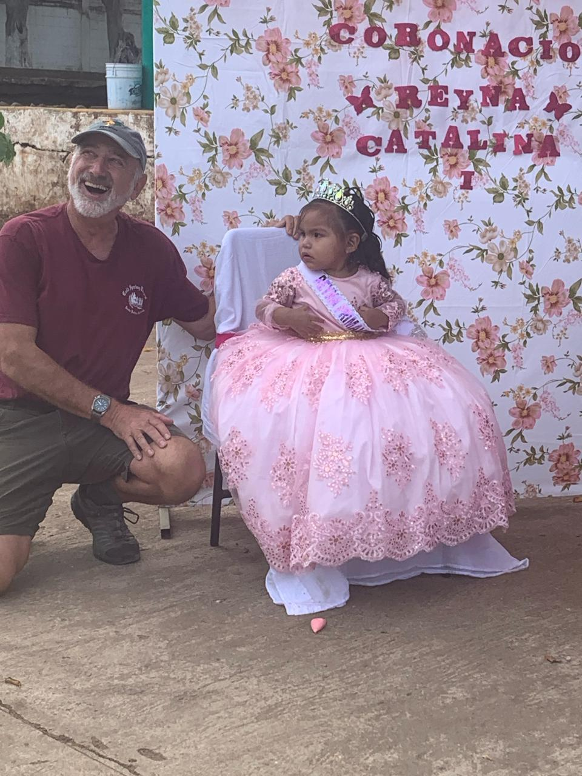
Mark and the Primavera Princess. With your help this Princess will help make Mexico the powerhouse of the future!
Mark y la princesa Primavera. ¡Con tu ayuda esta Princesa ayudará a hacer de México la potencia del futuro!

.

